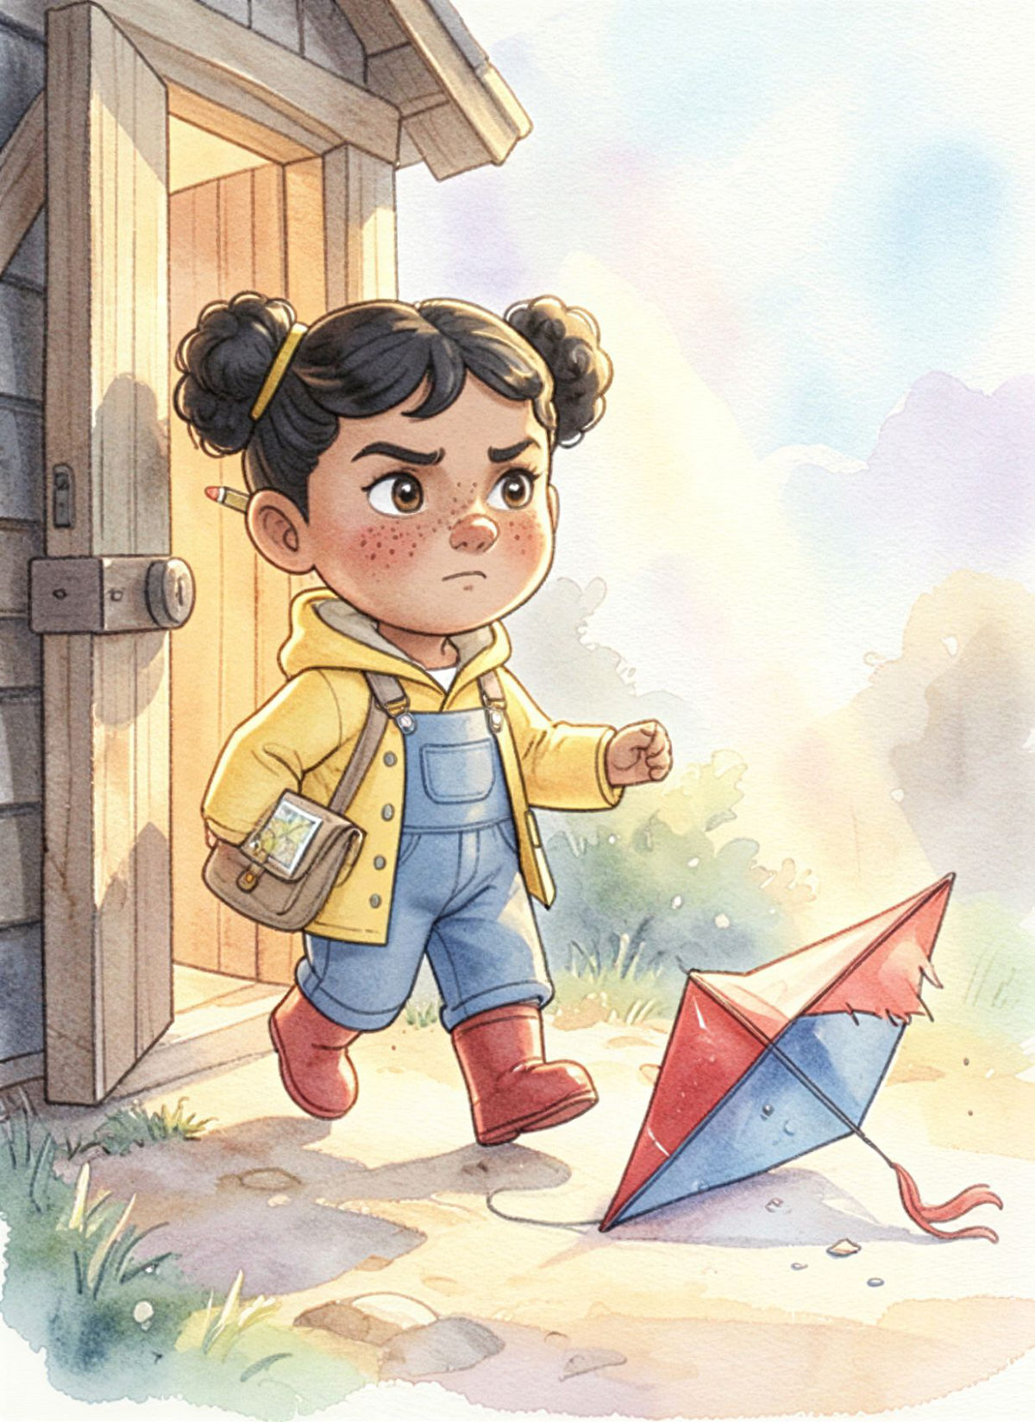

Wren and the Windmill Kite
Created with InkStak

Wren and the Windmill Kite
J.C. Logan

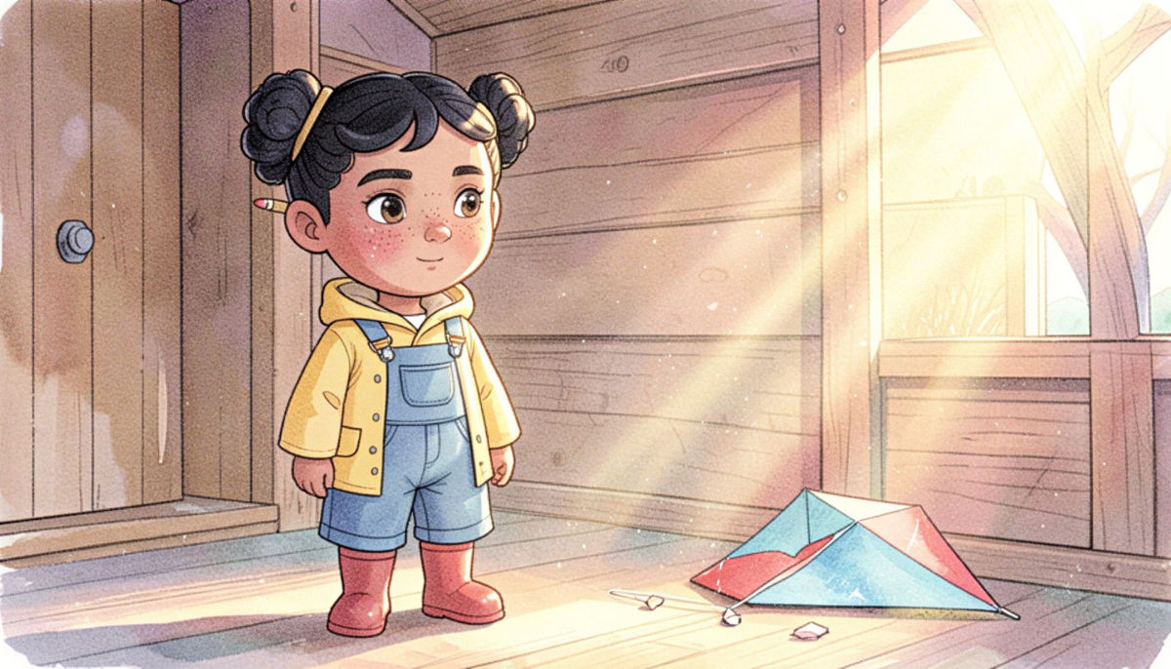
Wren climbed up to the windmill door.
She paced the steps: one, two, three, four.
Inside, in the dust and the sunbeam's glow,
lay a kite with a tear and a tail hanging low.

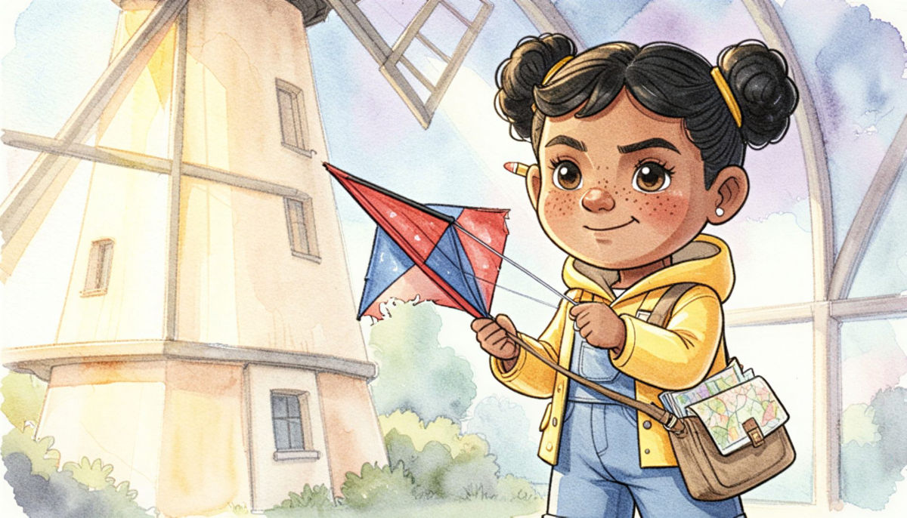
'Poor kite,' said Wren, with a gentle sigh.
'I'll mend you so you can fly high!'
She took up the kite in her two careful hands
and tucked it beside her paper maps and plans.

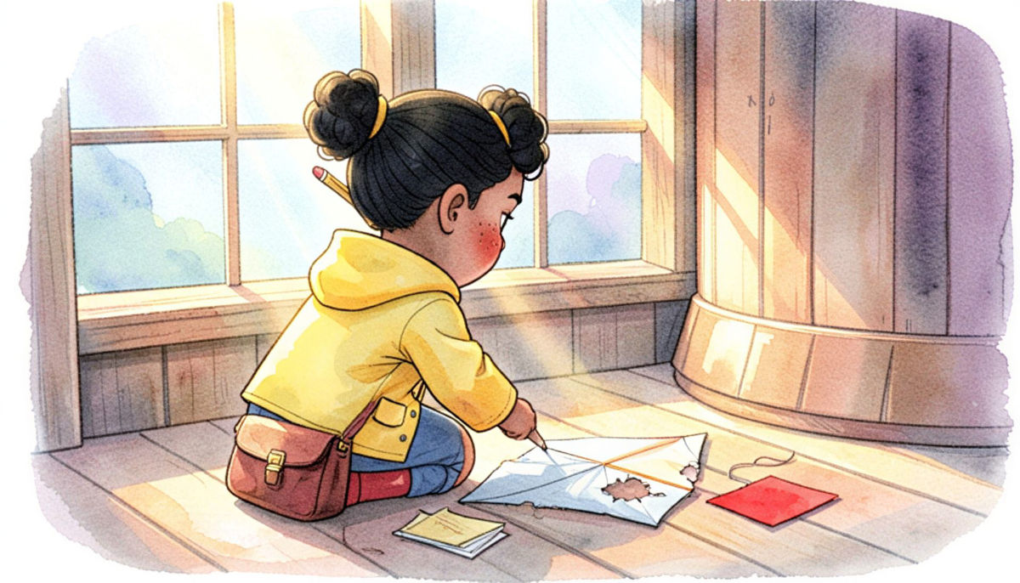
On the windmill floor, she measured the tear.
Her pencil stub counted, with the most gentle care.
She cut a new patch from a sheet of bright red,
then tied on a ribbon of string for the thread.

